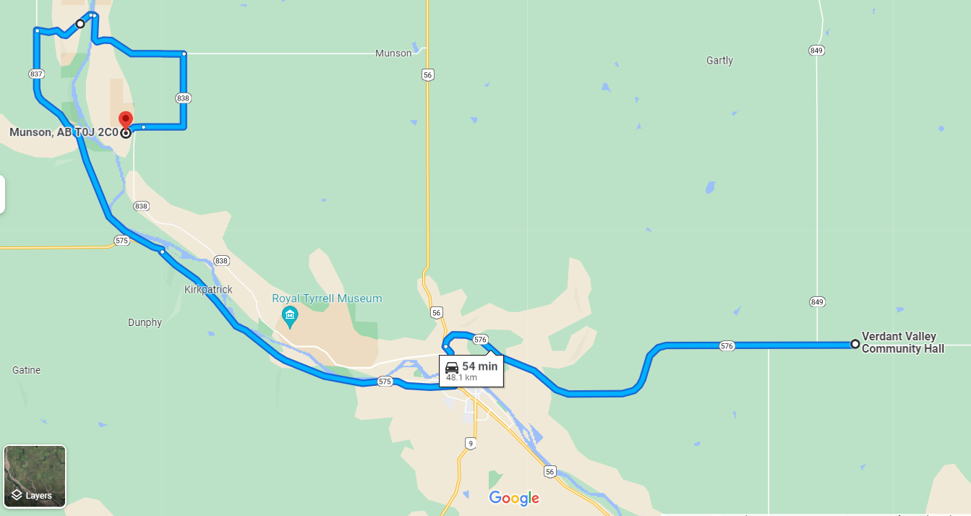
Route from Verdant Valley Hall to Horsethief Canyon (GPS Link https://cutt.ly/JJY0gPN ... Original Verdant Valley Hall, Rosedale, AB to Munson, Alberta T0J 2C0 - Google Maps
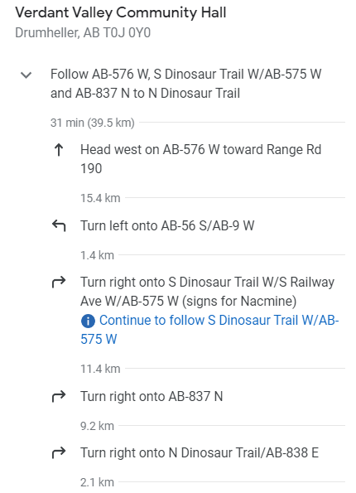
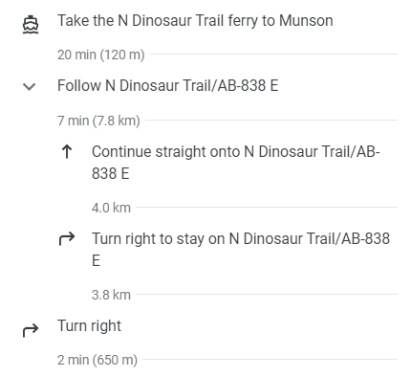

Route from Horsethief Canyon to Verdant Valley Hall (GPS Link https://cutt.ly/VJY0JSa ... Original link Munson, Alberta T0J 2C0 to Verdant Valley Hall, Rosedale, AB - Google Maps)
